**Question 37. (8 marks) [from WATP Sem II exam 2013]**

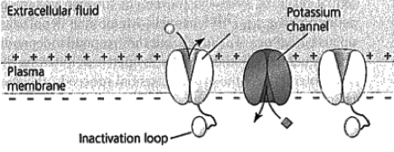

A

The diagram above represents an axon of a nerve cell membrane prior to an action potential occurring.

(a) What substance would be able to pass through structure A when an action potential occurs? (1 mark)

________________________________________________________________________________

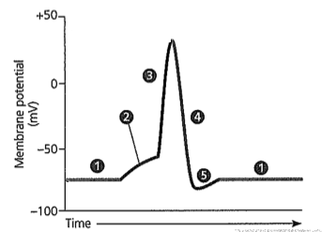

Diagram 2

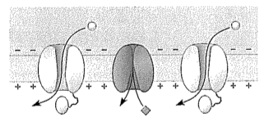

(b) Which part of the action potential shown in the graph above (1, 2, 3, 4, or 5) would Diagram 2 depict? (1 mark)

________________________________________________________________________________

(c) Explain how a sodium potassium pump maintains the level of ions required for a resting nerve cell membrane. (3 marks)

________________________________________________________________________________

________________________________________________________________________________ ________________________________________________________________________________

________________________________________________________________________________

(d) Ouabain is a substance extracted from an African plant by the Somali people who use it to poison their arrow-heads in order to kill animals. A sufficient concentration of the chemical can bring down a hippopotamus. Scientists now know that ouabain prevents the sodium-potassium pumps in nerve cell membranes from working. In the presence of ouabain, what change would you expect to see in the resting potential of a nerve cell? (1 mark)

______________________________________________________________________________________________________________________________________________________________________________________________

(e) State two (2) ways in which the speed of action potentials can be increased.

(2 marks)

________________________________________________________________________________

________________________________________________________________________________

**Question 33 (11 marks) [from WATP Sem I 2016 Paper]**

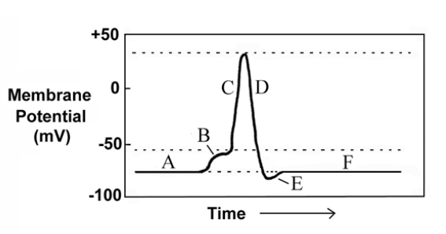Use the graph below, showing a nerve action potential, to answer the following questions.

1. Describe what is occurring during the phase indicated by the letter ”C”. (3 marks)

________________________________________________________________________________________________________________________________________________________________________________________________________________________________________________________________________________________________________________________________________________________________________________________________________________________________________________________________________________________________________________________

1. Discuss the differences between nerve impulse conduction along a myelinated and unmyelinated nerve fibre. (4 marks)

________________________________________________________________________________________________________________________________________________________________________________________________________________________________________________________________________________________________________________________________________________________________________________________________________________________________________________________________________________________________________________________________________________________________________________________________

1. A nerve impulse is described as an “all or nothing” action. If this is correct, explain why a person can tell the difference between a lump of heavy metal and a bread roll being dropped on their foot. (2 marks)

________________________________________________________________________________________________________________________________________________________________________________________________________________________________________________________________________________________________________________________________________________________________________________________________________________________________________________________________________________________________________________________________________________________________________________________________